TECAN Conversion to ECHO (pseudocode)

// commands:

// A – aspirate

// D – dispense

// W – wash (clean up for TECAN)

// R – reagent dispense

// general format:

// **Reagent**

Guess:

Command_type;source_name;;Source_type;Tip_number;tip_?;destination_type;destination_type;range(wells_distr);vol(wells_distr);enzyme;num_reuse_tips;?;?;

Actual:

R;**AspirateParameters**;**DispenseParameters**;Volume;LiquidClass;

NumOfDitiReuses;NumOfMultipleDispensers;Direction[;ExcludeDestWell]*

**AspirateParameters**

= SourceRackLabel;SourceRackId;SourceRackType;

SourcePositionStart;SourcePositionEnd;

**DispenseParameters**

=

DestinationRackLabel;DestinationRackId;DestinationRackType;

DestinationPositionStart;DestinationPositionEnd;

Main Parameters for Aspirate + Dispense:

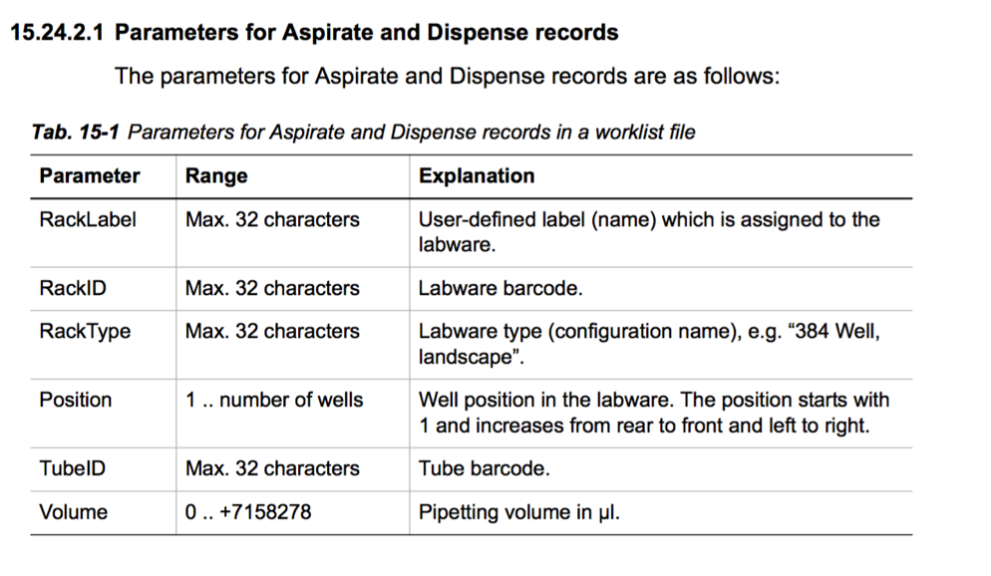

Main parameters for Reageant Distribution records

(aspirate / dispense):

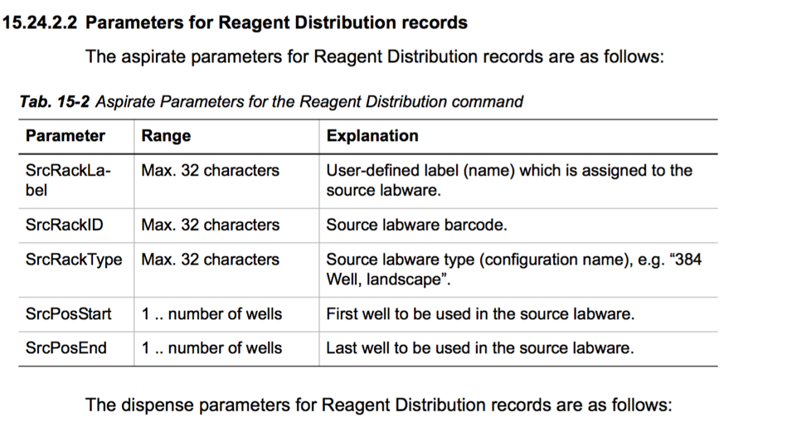

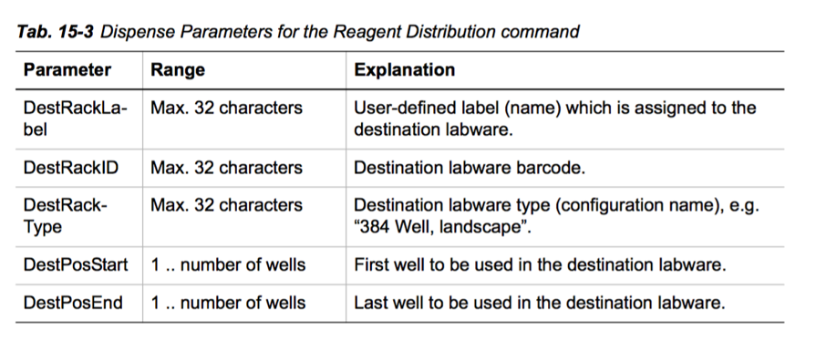

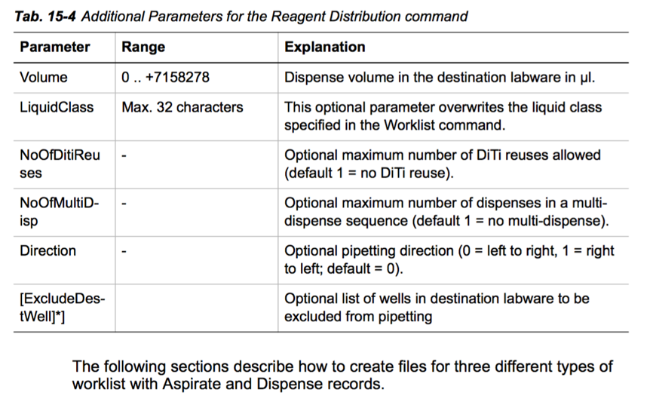

// **Aspirate**:

Guess:

Command_type;source_name;;source_type;;source_location;;volume

Actual:

A;RackLabel;RackID;RackType;Position;TubeID;Volume

// **Dispense**:

Command_type;source_name;;source_type;;source_location;;volume

Attempted translation to English (for psuedocode):

(try the first 20 commands and see if Luis approves)

1. Dispense the reagent plate1 from the source 96 well microplate, from tip 1 with quantity 1, onto the wells 1 to 33 on the destination 96 well microplate, with ENZYME 1000 at volume of 6.0 liters;
2. Dispense the reagent plate1 from the source 96 well microplate, from tip 2 with quantity 2, onto the wells 34 to 66 on the destination 96 well microplate, with ENZYME 1000 at the volume of 6.0 liters;
3. Dispense the reagent plate1 from the source 96 well microplate, from tip 3 with quantity 3, onto the wells 67 to 96 on the destination 96 well microplate, with ENZYME 1000 at the volume of 6.0 liters;
4. Aspirate on source setup plate1 onto destination 96 well microplate 20 with volume of 2.0 liters;
5. Dispense on source plate1 in 96 well microplate 1 with a volume of 2 liters;
6. TECAN robot wash step;
7. Aspirate